LACROSSE

INSTRUCTIONS

This Learning Packet has two parts: (1) text to read and (2) questions to answer.
The text describes a particular sport or physical activity and relates to its history, rules, playing techniques, scoring, notes and news.
The Response Forms (questions and puzzles) check your understanding and appreciation of the sport or physical activity.

INTRODUCTION
Lacrosse, considered to be America's first sport, was born of the North American Indian, christened by the French, and adapted and raised by the Canadians. Modern lacrosse has been embraced by athletes and enthusiasts of the United States and the British Commonwealth for over a century.
The sport of lacrosse is a combination of basketball, soccer and hockey. Anyone can play lacrosse—the big or the small. The game requires and rewards coordination and agility, not brawn. Quickness and speed are two highly prized qualities in lacrosse. An exhilarating sport, lacrosse is fast-paced and full of action. Long sprints up and down the field with abrupt starts and stops, precision passes and dodges are routine in men's and women's lacrosse. Lacrosse is played with a stick, the crosse, which must be mastered by the player to throw, catch and scoop the ball.
HISTORY OF THE GAME
Lacrosse is the oldest sport in North America. Rooted in Native American religion, lacrosse was often played to resolve conflicts, heal the sick, and develop strong men. To Native Americans, lacrosse is still referred to as "The Creator's Game.'
Ironically, lacrosse also served as a preparation for war. Legend tells of as many as
(0
1,000 players per side, from the same or different tribes, who took turns engaging in a violent contest. Contestants played on a field from one to 15 miles in length, and games sometimes lasted for days. Some tribes used a single pole, tree or rock for a goal, while other tribes had two goalposts through which the ball had to pass. Balls were made out of wood, deerskin, baked clay or stone.
The evolution of the Native American game into modern lacrosse began in 1636 when Jean de Brebeuf, a Jesuit missionary, documented a Huron contest in what is now southeast Ontario, Canada. At that time, some type of lacrosse was played by at least 48 Native American tribes scattered throughout what is now southern Canada and all parts of the United States. French pioneers began playing the game avidly in the 1800s. Canadian dentist, W. George Beers, standardized the game in 1867 with the adoption of set field dimensions, limits to the number of players per team and other basic rules.
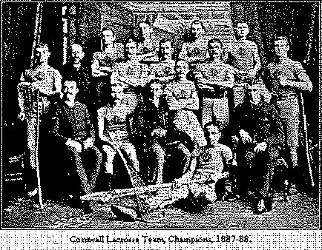
New York University fielded the nation's first college team in 1877, and Philips Academy, Andover (Massachusetts) , Philips Exeter Academy (New Hampshire) and the Lawrenceville School (New Jersey) were the nation's first high school teams in 1882. There are now 400 college and 1,200 high school men's lacrosse teams from coast to coast.
The first women's lacrosse game was played in 1890 at the St. Leonard's School in Scotland. Although an attempt was made to start women's lacrosse at Sweet Briar College in Virginia in 1914, it was not until 1926 that Miss Rosabelle Sinclair established the first women's lacrosse team in the United States at the Bryn Mawr School in Baltimore, Maryland.

HOW LACROSSE IS PLAYED
Men's Rules
Men's lacrosse is a contact game played by ten players: a goalkeeper, three defensemen, three midfielders and three attackmen. The object of the game is to shoot the ball into the opponent's goal. The team scoring the most goals wins.
Each team must keep at least four players, including the goalie, in its defensive half of the field and three in its offensive half. Three players (midfielders) may roam the entire field.
Generally, high school games are 48 minutes long, with 12 minute quarters.
Each team is given a two minute break 2 between the first and second quarters, and the third and fourth quarters. Halftime is ten minutes long.
Teams change sides between periods. Each team is permitted two time-outs each half. The team winning the coin toss chooses the end of the field it wants to defend first.

Men's lacrosse begins with a face-off. The ball is placed between the sticks of two squatting players at the center of the field. The official blows the whistle to begin play. Each face-off player tries to control the ball. The players in the wing areas can release; the other players must wait until one player has gained possession of the ball or the ball has crossed the goal line.
Center face-offs are also used after a goal and at the start of each quarter. Players may run with the ball in the crosse, pass and catch the ball. Only the goalkeeper may touch the ball with his hands.
A player may gain possession of the ball by dislodging it from an opponent's crosse with a stick check, which includes the controlled poking and slapping of the stick and gloved hands of the player in possession of the ball.
Body checking is permitted if the opponent has the ball. However, all contact must occur from the front or side, above the waist and below the shoulders. An opponent's crosse may also be stick checked if it is within five yards of a loose ball or ball in the air.
If the ball or a player in possession of the ball goes out of bounds, the other team is awarded possession of the ball. If the ball goes out of bounds after an unsuccessful shot on goal, the player nearest to the ball when and where it goes out of bounds is awarded possession.
An attacking player cannot enter the crease around the goal, but may reach in with his stick to scoop a loose ball.
Women 's Rules
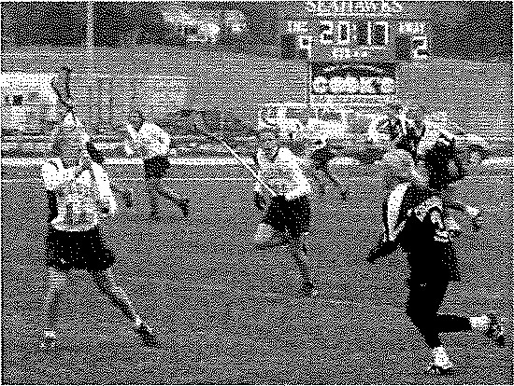
Before the game begins, the umpires check every stick for legality. The most common illegality in a stick is that its pocket is too deep. The strings at the bottom of the stick's head can be pulled to tighten the pocket.
If a player commits a foul, the umpire blows the whistle and play stops. The player fouled wins or retains the ball, while the player who fouled her is moved several yards behind or to the side of the player she fouled.
If a major foul is committed in the arc by the defense, the umpire blows the whistle, and a "free shot" on goal is taken by the player fouled. All of the defense players are required to clear the arc to the border closest to which they were standing when the whistle blew. The attack player who was fouled takes her place at the hash mark closest to which she was standing when she was fouled. The defense must move away at least four meters from the fouled player. When the umpire blows the whistle again, the player can take a shot on goal or pass while the defense moves in.
There are no boundaries to the field, but if a ball enters an area that is dangerous, unplayable or not clearly visible to the umpire, the player who retains it or is closest to it (if the ball has been grounded), at the umpire's whistle wins it. The player then waits for the second whistle to begin play again, either by running with or passing the ball.
When the umpire blows the whistle because a foul has occurred, or the ball has gone "out of bounds" all players must stop and check all forward movement. Play resumes and the players can move when the umpire blows the whistle again.
Checking the method by which a player knocks the ball from another's stick — is prohibited when it is: directed toward the face, uncontrolled, holding down the other's stick, or when the checker's stick is too close to the head or face.
Defensemen may not remain in the arc without guarding another player for more than

three seconds.
When the ball is grounded, covering it with the back of a stick's net, and preventing play by another player is prohibited.
No players, other than the goalie, may enter the circle around the goal cage if the goalie is present.
When a foul occurs, the player who was fouled is allowed a free shot at the goal, with the defense pushed to the perimeter around the arc.

TYPES OF LACROSSE
Box Lacrosse is played on a standard sized arena floor and features six players (goaltender and five runners) of an 18-20 player team on the floor at one time. The strategy of Box Lacrosse is similar to that of basketball, with all five runners involved in the offense and the defense. Added to the appeal are the speed and excitement created by a 30 second shot clock. The combination of action and reaction makes Box as much fun to play as it is to watch.
Box Lacrosse is played almost exclusively in Canada, with annual National Championships occurring at several levels. The award of the junior (17-21) championship is the Minto Cup, while the best senior players in Canada (over 21) play for the Mann Cup.
Men's Field Lacrosse is played outdoors on a 100m x 55m field. Teams consist of ten players of a team roster of 20-23 players. The team on the field consists of goaltender, attack, midfielders and defense. Men's Field is very similar to Box in the fundamental skills of passing and catching, and the physical nature of the play. The games differ in the style of play and strategy. There is no controlling shot clock in Men's Field and the game is more strategic and relies more heavily on possession and control of the ball.
Women's Field Lacrosse is a quick, free-flowing game which is easy to understand and watch. The game is played on a 100m x 55m field with twelve players on each side on the field. The full roster of a Women's Field team is 16-20 players. Unlike Men's Field or Box Lacrosse, Women's Field is a non-contact sport. There is no aggressive checking with either the stick or the body. This results in a game which has added emphasis on a fast-paced, polished game centered on ball movement

SKILLS & TECHNIQUES
Body Check: Contact with an opponent from the front - between the shoulders and waist - when the opponent has the ball or is within five yards of a loose ball.
Check-up: A call given by the goalie to tell each defender to find his man and call out his number.
Clamp: A face-off maneuver executed by quickly pushing the back of the stick on top of the ball.
Clearing: Running or passing the ball from the defensive half of the field to the attack goal area.
Face-Off: A technique used to put the ball in play at the start of each quarter, or after a goal is scored. The players squat down and the ball is placed between their crosses.
Fast-Break: A transition scoring opportunity in which the offense has at least a one-man advantage.
Pick: An offensive maneuver in which a stationary player attempts to block the path of a defender guarding another offensive player.
Rake: A face-off move in which a player sweeps the ball to the side.
Riding : The act of trying to prevent a team from clearing the ball.

EQUIPMENT & CLOTHING
The Crosse: The crosse (lacrosse stick) is made of wood, laminated wood or synthetic material, with a shaped net pocket at the end. The crosse must be an overall length of 40 - 42 inches for attackmen and midfielders, or 52 - 72 inches for defensemen.
The head of the crosse must be 6.5 - 10 inches wide, except a goalie's crosse which may be 10 - 12 inches wide. The pocket of a crosse shall be deemed illegal if the top surface of a lacrosse ball, when placed in the head of the crosse, is below the bottom edge of the side wall.
The Ball: The ball must be made of solid rubber and can be white, yellow or orange. The ball is 7.75 - 8 inches in circumference and 5 5.25 ounces.
The Helmet: A protective helmet, equipped with face mask, chin pad and a cupped four point chin strap fastened to all four hookups, must be worn by all men's players.
The Gloves: All players are required to wear protective gloves. The cutting or altering of gloves is prohibited.
The Mouthpiece: The mouthpiece must be a highly visible color and is mandatory. Clear mouthpieces are not allowed.
Protective Equipment: Shoulder Pads: All players, with the exception of the goalkeeper, must wear shoulder pads.

LACROSSE NEWS & NOTES
PROFESSIONAL LACROSSE
In November of 1986, the National Lacrosse League was formed as a professional lacrosse league. In 2006 eleven teams composed the NLL. The West Divsion is made up of the following six teams: Portland, Colorado, Calgary, Arizona, San Jose and Edmonton. The East Divison is comprised of five teams. They are: Buffalo, Rochester, Toronto, Minnesota and Philadelphia. Each team plays a sixteen game schedule during the regular season.
Eight of the teams competed in the 2006 NLL Playoffs. Buffalo Bandits and the Colorado Mammoths faced off in the championship game. Colorado handed Buffalo a 16-9 defeat in Colorado's first ever NLL championship.
The Major League Lacrosse organization created a professional field lacrosse league in 2001. Currently there are ten teams that make up the "national league." In 2006 the league expanded to include: Chicago, Denver, and San Francisco. Los Angeles, joined the league in 2005. The expansion teams comprise the Western Division while the six original teams are members of the Eastern Division. The franchise consists of the Baltimore Bayhawks, Boston Cannons, Long Island Lizards, New Jersey Pride, Philadelphia Barrage, Rochester Rattlers, Chicago Machine, Denver Outlaws, Los Angeles Riptide and the San Francisco Dragons. The 2005 season came to a finish with the Baltimore Bayhawks winning their second Major League Lacrosse Championship.
In NCAA actions, top seated Virginia defeated UMass 15-7 in the men's 2006 Division I Lacrosse Championship finals. Virginia finished the season undefeated. The Cavaliers were led by Matt Wards' five goals, becoming the first team to go 17-0 in a season.
Northwestern defeated Dartmouth 7-4 to win its second straight women's national title. The Wildcats scored five goals in the second period to rally from a 3-2 halftime deficit.
Once a minor pastime played in the shadows of baseball stadiums in the Northeast of the United States, lacrosse has become a national sport with more than 250,000 active players.
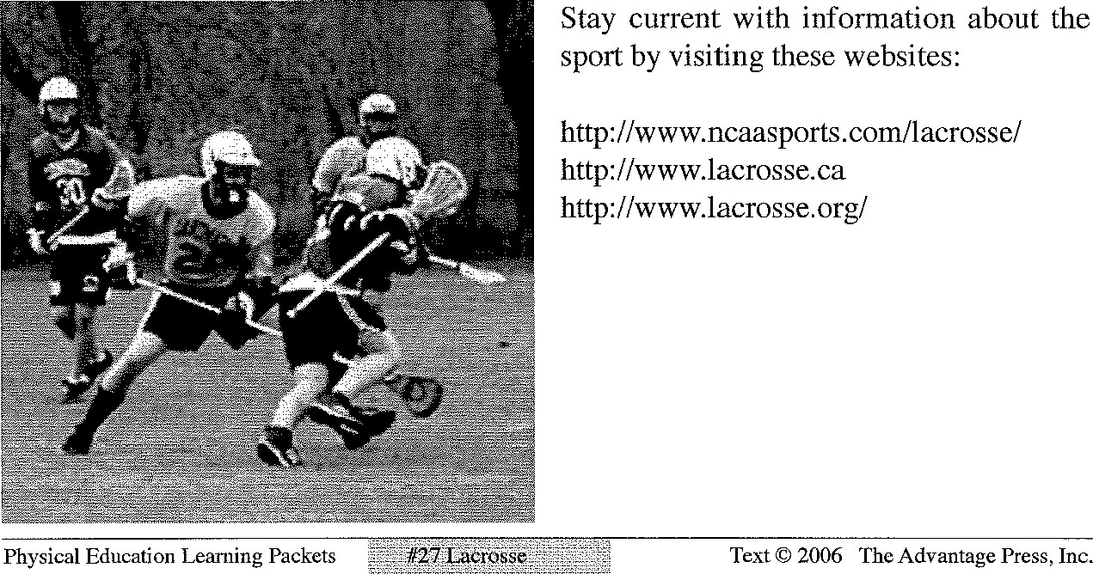

STUDENT RESPONSE PACKET

LACROSSE
NAME
DATE
WHAT TO DO
The following questions will help you to have a greater appreciation and understand of lacrosse. Write your answers in the spaces below the questions. If there is not enough room, write on the backs of these pages. Be neat, spell correctly, and write in complete sentences.
- Describe the history of the sport of lacrosse.
- How did lacrosse evolve from the haphazard play of the numerous tribes to the organized sport it is today?
- Describe how lacrosse is played.
- What are "face-offs?" How are they used?
- How are men's and women's lacrosse different?
- The sport of lacrosse is the combination of three sports. Name them.
- In what ways was lacrosse a good preparation for war?
- Describe the beginning of women's lacrosse.
- Describe the roles of the ten players on a men's lacrosse team.
- Describe how body checking may be used in lacrosse.

Name______________ Date: ________________ Due date: _____________

ACROSS
3 The name of the stick
- pioneers began playing lacrosse in the 1800s
- Considered to be America's "first sport"
8 They may roam the entire field
- Native Americans still refer to lacrosse as the ' game"
- The first women's game was played in this country
- Defensive players must move meters away from a foul shot
- This is not required to be good at the sport
- Men's lacrosse is a game
- She established the first women's lacrosse team
Down
I This is a highly prized quality in this sport
2 Lacrosse was often played to resolve these
4 Lacrosse is a combination of three sports. This is one. 7 They adapted and raised the sport to its' current status
- Jean de Brebeuf was one
- One of the first high schools to play the game
- The team scoring the most of these, wins
13 Each team must keep at least four players in the half of the field
- The stick is if its' pocket is too deep
- Only the goalie can enter the around the goal cage

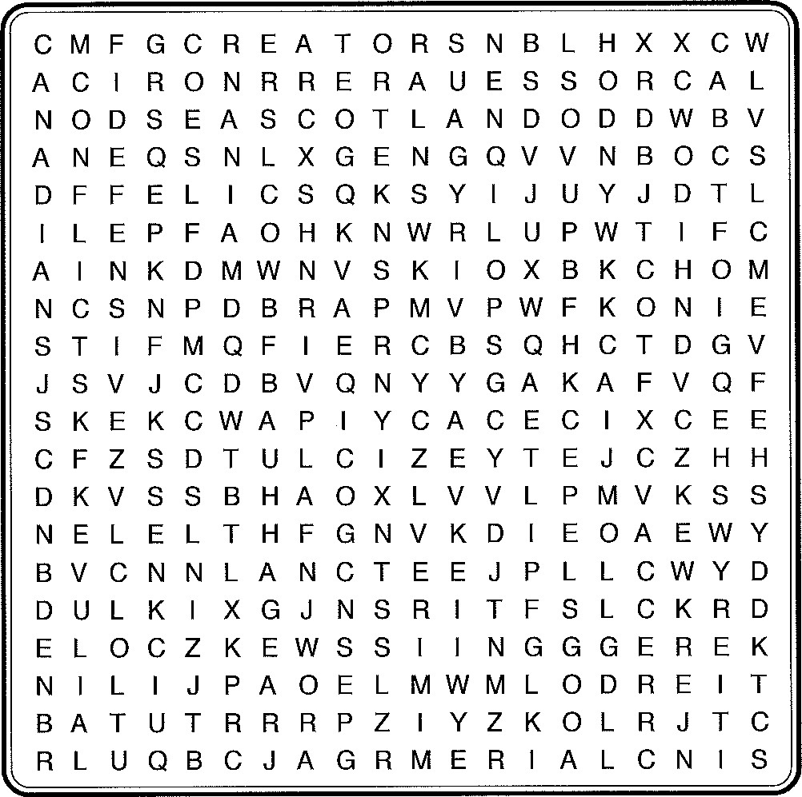
tri
o
to
Circle the words in the above puzzle.
 | 11. HOCKEY
2. CANADIANS | 12. LACROSSE
3. CIRCLE | 13. LAWRENCEVILLE
4. CONFLICTS | 14. MIDFIELDERS
5. CONTACT | 15. MISSIONARY
6. CREATORS | 16. POCKET
7. CROSSE | 17. QUICKNESS
8. DEFENSIVE | 18. SCOTLAND
9. FRENCH | 19. SINCLAIR
10. GOALS | 20. STICK

